 **ANNA UNIVERSITY**

**NAAN MUDHALVAN – GUIDED PROJECT**

**TRANSPARENT EDUCATION DATA MANAGEMENT**

PROJECT PLANNING AND ESTIMATION

|  |  |
| --- | --- |
| Date | 31October 2023 |
| Team Members | 1. DHARUN M -  0270CBCD3358D93874A40B917EEC65EC 2. DIVYA DHARSHINI -  087EE4C0342F965ADBA46 49B908C2642 3. ELASUKUMARAN E - 23556780714CDCFB5B84BF4E9269022A 4. GOWTHAM R -  0BF3F06AC53C10E89F446EF2C7C77B3C 5. VYSHNAVI M - 4284E4FD1316A93BEA54DC B745B8F87F |
| Project Name | Transparent Education Data Management |
| Maximum Marks | 10 Marks |

TECHNOLOGY ARCHITECTURE

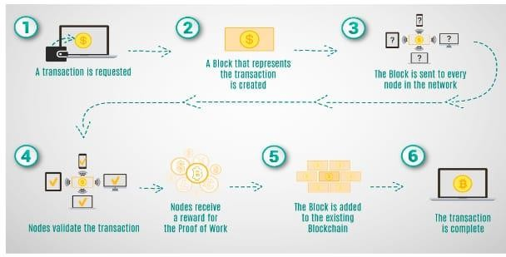

TECHNOLOGY STACK

